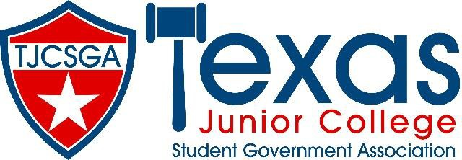

Advisors Association Meeting
Dallas Texas

Addison/Dallas Marriott Quorum
Friday, March 25, 2022 (9:00am –11:50am)

- Call to Order- 9:30 am
- Roll Call- led by Courtney Skiles-TVCC, explains that minutes and agendas are available on the website. 42 advisors present. Quorum met. Courtney yields back to Madam President.
- Approval of Minutes- board entertains a motion to approve the minutes as presented on the website. Kenneth Webb- PJC moves, advisor from TCC-Southeast 2nds. Motion carries.
- Officer Reports
  - State Advisor- Dr. Beth Nikopolous- Not present.
  - State Advisor- Elect (Pro Temp) – Stephen Rogers- Thank you to first time advisors, welcome back to veterans. Thank you for bringing students back, its better than being virtual. Nice being able to engage with students and getting out numbers back up again. Advisors are here to support you. Explains why he is pro-temp and announces that he is not going to be running for the state advisor elect candidate. Explains role of advisor elect.
  - Editor- Courtney Skiles- Explains how to access website, minutes, and agenda.
  - Vice President- Rolando Martinez- welcome and introduction. No other report.
  - President- Kelly Sonnanstine- welcome. Thank you for coming. Running for nominations today. The AA president works with state advisor to pick new locations for future conventions. Convention locations: next years convention is back at the Marriot Quorum Hotel in Addison, TX. Madam President yields her time to Stephen Rogers to further explain the convention location meetings. 2024/2025 possible locations: Lubbock, Austin, Ft. Worth, San Antonio, and 2025 will be in Galveston, hopefully. Looking for dates at these locations, but convention next year will be in April. Stephen Rogers yields back to Madam President. Future board will start looking for 2026, and why Galveston is being picked for 2025.

- Committee Reports- No reports.

- Unfinished Business
  - Judicial Issues- None so far, this is just to prepare in case there are future judicial issues.

- New Business
  - Nominations for State Advisor Elect
    - Rolando Martinez- NC-Corsicana was nominated by Stephen Rogers. Rolando accepts
    - Stephen Rogers nominates Miyoshi Holmes. She is absent, so Stephen Rogers moves to table this article of business until we can get confirmation from Miyoshi. Kenneth Webb- PJC 2nds, motion carries.

- Announcements
  - Advisors Association Positions- we will open these positions tomorrow for nominations and voting. Questions: what does secretary do? Courtney explains.
  - Chance Drawing- Courtney moves to postpone this until she can get the website to work. Colby Calhoun-TVCC moves, 2nd, motion carries.
    - Courtney fixes it, DC-Cedar Valley and Collin college win mugs.
  - Advisor Reception- food and fun! Please come.

Madam president entertains a motion to recess for 5 minutes so she can go talk to Miyoshi about her nomination. Kenneth Webb-PJC moves, Colby Calhoun-TVCC 2nds, motion carries.

Call to order after recession at 10:06 am,
  - Mioyshi has accepted her nomination. Stephen Rogers moves to close the floor for nominations, Kenneth Webb-PJC 2nds, motion carries.
- Adjournment/Reminders- Colby Calhoun-TVCC motions, Kenneth 2nds. Meeting adjourned at 10:07 am.

Training/Discussion Panel to follow the meeting.

