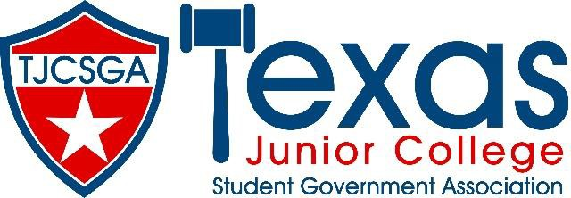

Advisors Association Meeting
Dallas Texas

Addison/Dallas Marriott Quorum
Friday, March 25, 2022 (9:00am –11:50am)

- Call to Order
- Roll Call
- Approval of Minutes
- Officer Reports
  - State Advisor- Dr. Beth Nikopolous
  - State Advisor- Elect (Pro Temp) – Stephen Rogers
  - Editor- Courtney Skiles
  - Vice President- Rolando Martinez
  - President- Kelly Sonnanstine

- Committee Reports

- Unfinished Business
  - Judicial Issues

- New Business
  - Nominations for State Advisor Elect

- Announcements
  - Advisors Association Positions
  - Chance Drawing
  - Advisor Reception

- Adjournment/Reminders

Training/Discussion Panel to follow the meeting.

