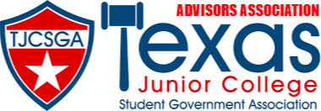

ADVISORS ASSOCIATION MEETING AGENDA
Dallas, Texas
Addison/Dallas Marriott Quorum
Saturday, April 15,2023, 10:00 am

- Call to Order
- Roll Call
- Approval of Minutes
- Officer Reports
  - State Advisor-Elect- Frankie Ward
  - State Advisor- Myoshi Holmes
  - Editor- Kaymon Farmer
  - Vice President- Kelly Sonnanstine
  - President- Kenneth Webb
- Committee Reports
- Unfinished/Old Business
- New Business –
  - Election of Officers
  - State Advisor Elect Nominations
  - SGA 101
- Announcements
  - Advisor Reception- 9:30pm
- Adjournment

