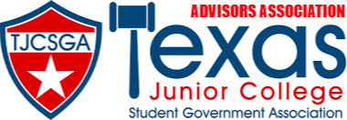

ADVISORS ASSOCIATION MEETING AGENDA
Dallas, Texas
Addison/Dallas Marriott Quorum
Friday, April 14, 2023, 9:00 am

- Call to Order
- Roll Call
- Approval of Minutes
- Officer Reports
  - State Advisor-Elect- Frankie Ward
  - State Advisor- Myoshi Holmes
  - Editor- Kaymon Farmer
  - Vice President- Kelly Sonnanstine
  - President- Kenneth Webb
- Committee Reports
- Unfinished/Old Business
- New Business
  - Nominations for State Advisor-Elect
  - Advisor Association Positions
- Announcements
  - Advisors Meeting- Saturday, April 15, 2023, at 10:00 am
  - Advisor Reception- 9:30 pm
- Adjournment

