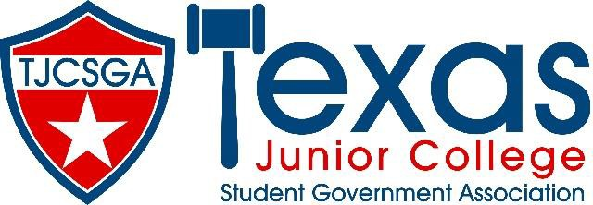

Advisors Association Meeting
Addison, Texas

Dallas/Addison Marriott Quorum
Saturday, March 26, 2022 (10:00am –11:50am)

- Call to Order
- Roll Call
- Approval of Minutes
- Officer Reports
  - State Advisor- Dr. Beth Nikopolous
  - State Advisor- Elect (Pro Temp) – Stephen Rogers
  - Editor- Courtney Skiles
  - Vice President- Rolando Martinez
  - President- Kelly Sonnanstine

- Unfinished Business
  - Judicial Issues
  - 501c3 status
  - State Advisors Elect Candidates
  - Advisor Association Executive Board positions

- New Business
  - TJCSGA Convention 2023
  - TJCSGA Convention 2024 – potential locations
  - TJCSGA Convention 2025 – potential locations

- Announcements/Reminders
  - Chance Drawing
  - Advisor Reception

- Adjournment

