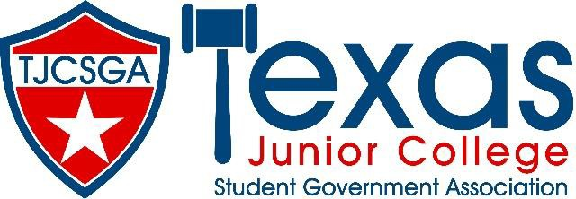

Advisors Association Meeting
Join Zoom Meeting
us02web.zoom.us/j/82476048746
Meeting ID: 824 7604 8746
Thursday, November 18, 2021

Call to Order: 12:01 p.m.

by Advisor’s Association President, Kelly Sonnanstine.

Roll Call:

Roll call was conducted via Zoom chat (see attachment for full attendance).

Approval of Minutes:

Minutes were presented by Courtney Skiles, TJCSGA Advisor’s Association Editor.

No objections were made, and minutes were approved as written using unanimous consent.

Additions to Agenda:

Agenda was presented by Kelly Sonnanstine. No additions were added. Motion passed by unanimous consent.

Officer Reports:

President- Kelly Sonnanstine:

No vice president for advisor’s association and James Jones stepped down from state advisor position.

State advisor-elect position was filled by discussion between state officers, Beth, and Kelly. Steven Rogers was chosen as advisor elect pro-tem.

Steven will only serve for this convention. We will need to nominate two people for state convention in March.

Vice President- Vacant

Editor- Courtney Skiles:

Turned down VP for advisor’s association position but is happy to serve as editor for the remainder of the year.

Reminds everyone to put name/college in the chat for roll call.

State Advisor- Beth Nikopolous:

State eboard meeting this past weekend, wanted to fill as many vacancies on state board as possible. Added secretary- Richland College, still missing a treasurer position.

State registration form will go live soon. All checks will go to TVCC until we have a treasurer. Please send forth students to fill the treasurer position.

Forms are added to website for dues, convention at a glance, and more.

Convention will be in person. Expecting a slightly smaller convention. We will be in Dallas for the next two years of convention due to contract negotiations.

Please look at the dues form. Submit before the holidays since the convention is sooner.

Competition guidelines are coming. When state eboard meets again they will discuss scrapbook… it wasn’t in the competition guidelines, so it did not get included in the competition guidelines for this year.

We will follow Dallas County covid guidelines for convention.

State eboard this year is great and is making great progress.

State Advisor-Elect, Pro-tem- Steven Rogers:

Excited to take on the roll as state advisor elect pro-tem. Was thankful to provide immediate relief to the board.

Convention 2023 is back in Dallas. Beth is looking into hotels in other areas for 2024.

Please look for a student to fill treasurer position. Would like region representation from outside of region 2 or 3, so we would like region 1, 4, 5 or 6 to fill the position.

There are a lot of schools that are struggling since covid, please support new advisors.

Please reach out for help, would like to help the regions and schools as much as possible. Thankful for the opportunity.

James resigned because he is having a child in March around the convention, but Steven is also having a child in January, but will still be able to be involved in everything leading up to state.

Wants to make sure all schools and region feels accepted and supported.

Old Business:

Open Eboard Position:

Kenneth Webb from Paris Junior college has a student who might be interested in treasurer. Should have an answer by Monday.

Wasn’t voted on at the eboard meeting because that student is also region 3 treasurer and there was some confusion.

New Business:

Advisors Association Positions VP position

Rolando Martinez from Navarro College Corsicana is interested.

No objections. Rolando Martinez is now VP.

TJCSGA Convention 2022

Location: Marriot Quorum Hotel in Addison

Costs: $250 of student cost, $275 advisors, hotel is $179/night for rooms, Late registration is $325.

Question: Is there a hotel limit to how many students can stay in a room due to covid? Looking into it.

Theme: Leaders with a Cause

Announcements:

Question from Rolando Martinez: Navarro college has advisors for Midlothian and Waxahachie but no students. They are going to pay their dues, but if they don’t have students, will there be a problem for voting?

Answer: need to have at least one student to represent the college to have full voting rights

The board pays the boards members and hotel room, and the food the day before the convention.

Richland college students are super excited and willing to help

Collin college was host school last year and is willing to help the current host school with their previous plans for the convention

Introductions from everyone

Adjournment: 12:40 p.m.

