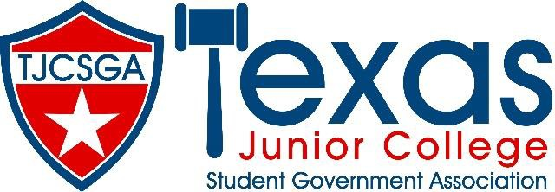

Advisors Association Meeting

Friday, March 26, 2021

- Call to Order
Meeting was called to order at 10:23 AM by Shanee’ Moore TJCSGA Advisor’s Association President.

- Roll Call
Roll call was conducted via Zoom chat (see attachment for full attendance).

- Approval of Minutes
Minutes were presented by Jacob-Aidan Martinez TJCSGA Advisor’s Association Editor. No objections were made and minutes were approved as written using unanimous consent.

- Additions to the Agenda
Agenda was presented by Shanee’ Moore. No additions were added.
- Stephen Rogers moved to approve meeting agenda.
  - Bryan Borski seconded the motion.
  - Motion passed by unanimous consent.

- Officer Reports
  - State Advisor Elect- Vacant
- Position Vacated. OL Kelley was appointed Advisor Elect Pro Tem. Encouraged advisors to get more involved with TJCSGA.
  - State Advisor- James Jones
- Informed advisors that 21 schools registered for conference. Stated there was a plan to get TJCSGA more active in the future.
  - Editor- Jacob-Aidan Martinez
- Welcomed advisors and gave well wishes.
  - Vice President- Beth Nikopoulos
- Thanked all advisors for their continued work. Reminded advisors that SGA is about advocacy in midst of pandemic and much will need to be rebuilt.
  - President- Shanee’ Moore
- No updates. Welcomed all advisors to the conference.

- Old Business
None

- New Business
  - Nominations for State Advisor Elect
- Shanee’ Moore opened the floor for nominations.
  - Beth Nikopoulos (Dallas College NorthLake) was nominated. Beth accepted nomination.
  - Stephen Rogers (Collin College) was nominated. Stephen accepted nomination.
- Since only two candidates were nominated, both were forwarded to the State Board.
  - Advisors Association Positions
- Shanee’ Moore opened the floor for nominations.
  - Courtney Skiles (Trinity Valley College) was nominated for Editor. Courtney accepted the nomination.
  - Brian Borski (Dallas College) was nominated for Vice President. Brian accepted the nomination.
  - Kelly Sonnastine (Richland College) was nominated for President. Kelly accepted the nomination.
- All positions were unopposed. Advisors agreed by unanimous consent to select nominated advisors for officer positions.
  - TJCSGA Convention 2022
- Conference is flat $15,000 to host from last year – former advisor signed an agreement.
- This year hosted virtual conference but officers were at location.
- In 2022 – conference will move back to Addison. Dates pending.
- In 2023 – conference will remain in Addison – April 12-15, 2023.
- In 2024 – new location will be selected.

- Announcements
No announcements.

- Adjournment
Shanee’ Moore adjourned the meeting at 10:52 AM.

